26th June 2017

**Petr Fulin back on top after Race of Portugal**

Petr Fulín and Zsolt Dávid Szabó were all smiles following the FIA European Touring Car Cup in the challenging streets of Vila Real in Portugal. The FIA ETCC has the Japanese premium tyre manufacturer YOKOHAMA as Official Tyre supplier.

Petr Fulín made the most of his rapid getaway to win Race 1, holding off pole-sitter Norbert Nagy throughout an exciting 11-lap encounter. Nagy tried everything to pass his Czech rival but had to settle for a career-best second instead, albeit by a slender margin of 0.530s. Igor Stefanovski was resisting ETCC rookie José Rodrigues for the final podium place but looked to have lost out when they collided on the penultimate lap, sending him into a half-spin. Stefanovski’s self-run SEAT suffered suspension damage in the incident, which left the Macedonian fuming and was also the subject of a post-race investigation by the stewards who penalised Rodrigues. Norbert Nagy, starting from pole, finished second in Race 1 with ETCC rookie José Rodrigues pleasing the home fans in third until he was handed a 30-second penalty following a clash with Igor Stefanovski, which dropped him to fourth and promoted Stefanovski one place.

Szabó’s victory in the shortened second race was his first in the series, while there was also a maiden ETCC podium for Plamen Kralev. Stefanovski completed the Race 2 podium to move ahead of Christjohannes Schreiber and into second behind new leader Fulín in the standings after the title pacesetter suffered his second double non-score of the season during a frustrating afternoon for the Rikli Motorsport Honda team.

Zsolt Dávid Szabó claimed his maiden victory in the FIA European Touring Car Cup in a shortened race featuring two safety car periods. Audi driver Plamen Kralev was in second when it was confirmed the race would not restart due to barrier damage with Igor Stefanovski in third. While Szabó made the perfect start, any hopes Norbert Nagy – his Zengő Motorsport team-mate – had of claiming the top step of the podium were extinguished when he was eliminated in a first-lap crash after he got off-line on the dirty side of the track. With his SEAT stranded, the safety car was deployed to enable its removal and for debris to be cleared. Racing resumed on lap four with Szabó ahead of Kralev and Christjohannes Schreiber, who had made a fast start from P11 to move into third place. But the Swiss would soon be in trouble with Stefanovski taking third on lap four as Schreiber began to slip down the order with a suspected mechanical fault before crashing out one lap later – when there appeared to be a failure at the right front – to trigger a second safety period. With the trackside barrier he struck beyond immediate repair the race was red-flagged before being declared after four laps, meaning half points only were awarded. José Rodrigues his ETCC debut in fourth with Petr Fulín fifth and Andreas Pfister in sixth.

Current Standings in the Championship:

1 Petr Fulin 57

2 Christjohannes Schreiber 44

3 Norbert Nagy 42

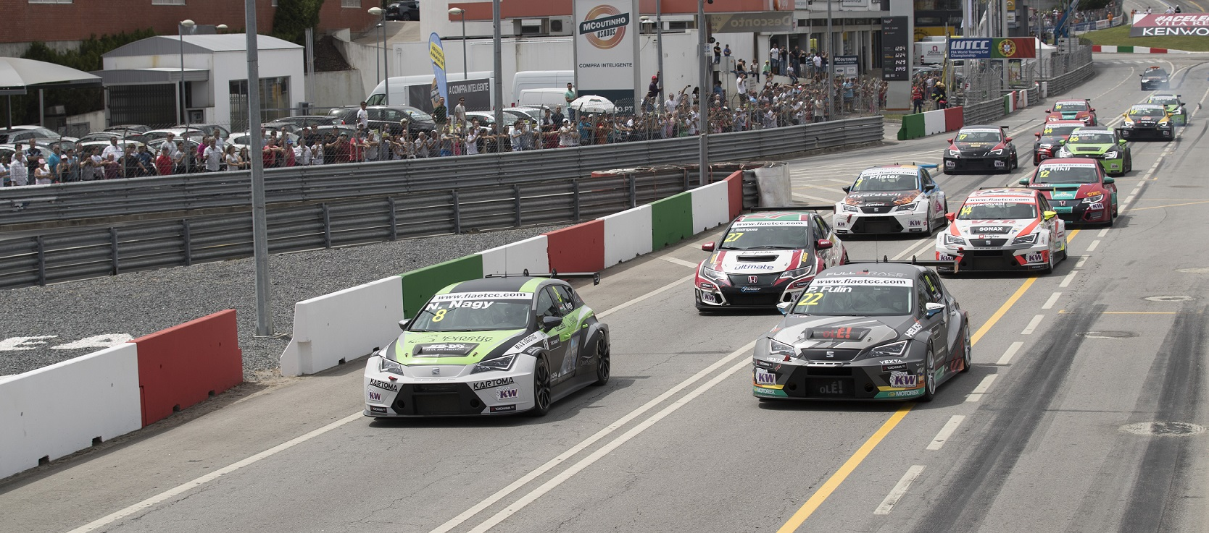

*ETCC Race action in Portugal*